MS
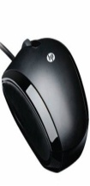 | HP KY619AA USB 2.0 | USB 2.0  Optical Technology  Windows XP, Windows Vista OS  3 Buttons  Black Color | Rs. 490 | 32 | Rs. 329
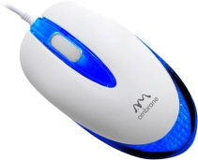 | Ambrane M-111 USB 2.0 | USB 2.0  Optical Technology  2 Buttons  Windows XP, Windows Vista OS  Ergonomic and Comfortable Design | Rs. 144 | 0 | Rs. 144
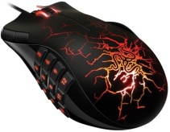 | Razer Naga USB 2.0 | USB 2.0  Optional MMO-specific  Optional MMO-specific software  17 MMO-optimized buttons  - 1000 Hz Ultrapolling | Rs. 6749 | 11 | Rs. 5999
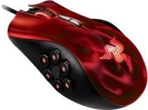 | Razer Naga Hex USB 2.0 | USB 2.0  - 5600dpi 4G Laser Sensor  - 11 Programmable Buttons  - 250 Clicks Per Minute  - Razer Synapse 2.0 | Rs. 6749 | 11 | Rs. 5999
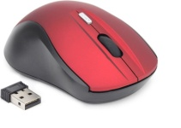 | DigiFlip WM001 Wireless | 2 Buttons  2 AAA Batteries  Optical Technology  Operating Range: 10 m  Adjustable DPI | Rs. 600 | 25 | Rs. 449
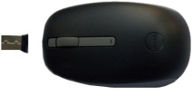 | Dell WM112 Wireless | 2 Buttons  Optical Technology  2 AAA Batteries  Operating Range: 10 m  Adjustable DPI | Rs. 625 | 0 | Rs. 625
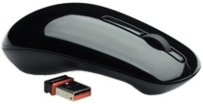 | Dell WM311 Wireless | 3 Buttons  2 x AAA Alkaline  Optical Technology  Mechanical Scroll Wheel  Wireless Range: 2.4 GHz | Rs. 1499 | 20 | Rs. 1195
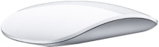 | Apple Magic Wireless | 2 Buttons  Laser Tracking Engine  Multi-touch Mouse  Mac OS X v10.5.8  Wireless Software Update 1.0 | Rs. 4975 | 0 | Rs. 4975
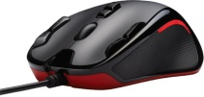 | Logitech G300 | USB 2.0  G300 Gaming  1000 Hz polling  9 programmable buttons  2500 dpi sensor | Rs. 1725 | 4 | Rs. 1650
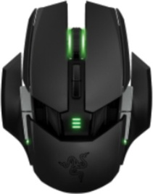 | Razer Ouroboros Elite | 3 Buttons  4G Dual Sensor System  1ms Gaming-grade  Wireless Technology  single AA battery | Rs. 12149 | 10 | Rs. 10890
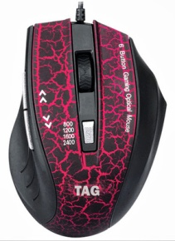 | TAG USB | 6 Buttons  optical mouse  2 Buttons  Windows XP, Windows Vista OS  Ergonomic and Comfortable Design | Rs. 1150 | 26 | Rs. 848
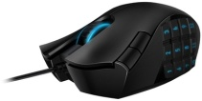 | Razer Naga USB | USB 2.0  17 MMO-optimized buttons  3.5G Laser Sensor  1000 Hz polling  5600dpi Razer Precision | Rs. 6749 | 9 | Rs. 6099

